House Price Analysis

House Price Data

ID unique identifier
Price price of home in dollars
SqFt square feet of area of home
Bedrooms number of bedrooms
Bathrooms number of bathrooms
Offers number of offers received on home before sale
Brick Yes/No on brick construction
Neighborhood location of home in east, west, or north quadrants of city

Outline and grading criteria (questions continued on next page):

- Develop a categorization of your data using pivot tables. (15% total):

  - Create one pivot table of average price, varying type of construction (brick) and neighborhood as the two dimensions. Copy the table into the report. (5%)

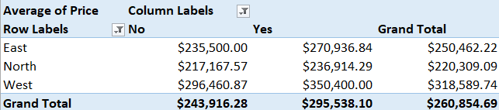

  - Create a second pivot table of average square feet, varying type of construction (brick) and neighborhood as the two dimensions. Copy the table into the report. (5%)

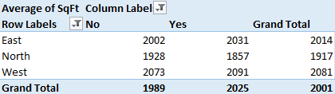

  - What patterns do you see in each pivot table? (5%)

Pivot Table 1 patterns:

- West has the highest average home prices, regardless of construction type.
- Brick homes are pricier on average in all three neighborhoods.
- North has the lowest average prices, making it the most affordable neighborhood in this dataset.

Pivot Table 2 patterns:

- Brick homes in the West neighborhood have the highest average square footage.
- Brick homes in the North neighborhood have the lowest average square footage.
- Brick construction does not consistently correspond to larger houses across all neighborhoods.

- Using the two pivot tables above, generate pivot charts (10% total)

  - Create a pivot chart of average price by type of construction (brick) and neighborhood. Copy the chart into the report. (5%)

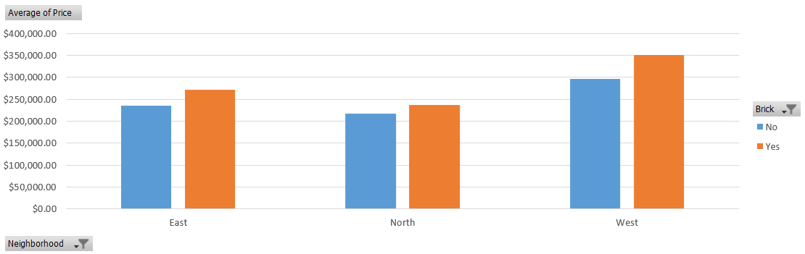

  - Create a pivot chart of average square feet by type of construction (brick) and neighborhood. Copy the chart into the report. (5%)

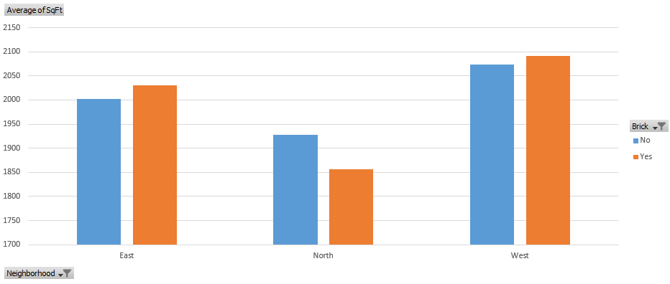

- Generate a table of descriptive statistics (mean, median, minimum, maximum) for price, square feet, bedrooms, bathrooms, offers. Copy the table into the report. (5%)

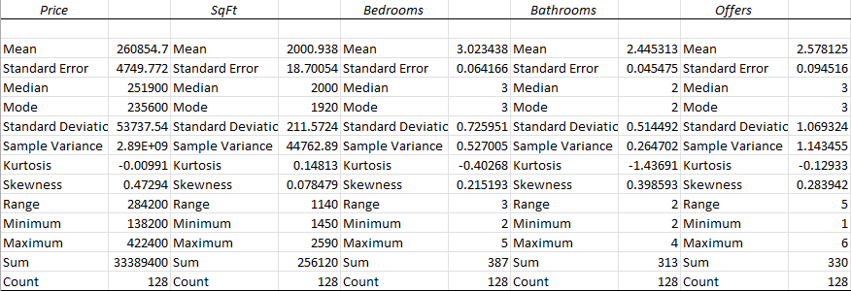

- Perform a correlation analysis of all quantitative variables except ID. (15% total)

  - Perform a correlation analysis of price, square feet, bedrooms, bathrooms, offers. Copy the correlation table into the report. (4%)

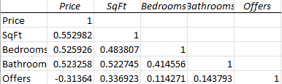

  - Which two variables have the strongest (largest magnitude) correlation? (3%)

Price and square feet have the strongest correlation. It is a positive relationship, which means that larger homes tend to command higher prices.

  - Which two variables have the weakest (smallest magnitude) correlation? (3%)

Bedrooms and offers have the weakest correlation. The number of bedrooms has little linear relationship with the number of offers a house receives.

  - Are these correlations intuitive? If not, why not? Justify your answer. (5%)

Most of the correlations are intuitive. Larger homes and those with more bedrooms or bathrooms tend to sell for higher prices, which is expected because buyers generally pay more for additional space and features. The negative correlation between price and offers is also plausible: higher-priced homes appeal to a smaller pool of buyers and therefore tend to attract fewer offers.

- Perform an initial regression analysis of the quantitative variables excluding the ID. (20% total)

  - Run one regression with price as the Y-variable and square feet, bedrooms, bathrooms, offers as the X-variables. Do not include type of construction or neighborhood. Copy the regression into the report. (4%)

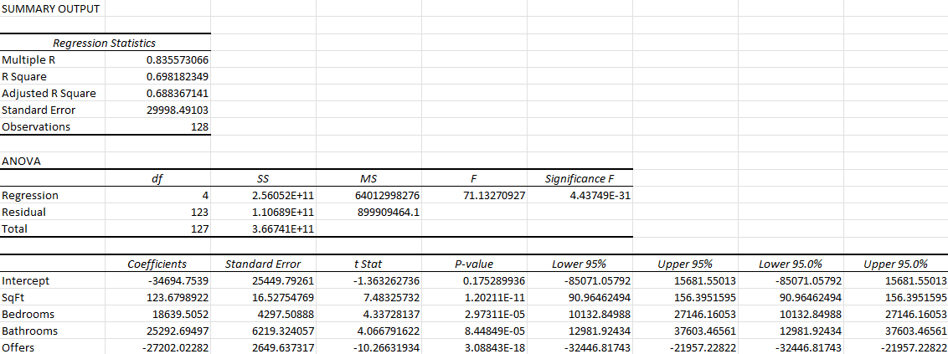

  - Which variables are statistically significant? (4%)

Square feet, bedrooms, bathrooms, and offers are all statistically significant predictors of price at p < 0.05.

  - What does each coefficient mean in business terms? (4%)

Square Footage: Each additional square foot is associated with a $123.68 increase in house price.

Bedrooms: Each additional bedroom is associated with an $18,639.51 increase in house price.

Bathrooms: Each additional bathroom is associated with a $25,292.69 increase in house price.

Offers: Each additional offer is associated with a $27,202.02 decrease in house price.

Intercept: The model predicts a price of -$34,694.75 when all independent variables equal zero.

  - Are these coefficients intuitive? If not, why not? (4%)

Most of the coefficients are intuitive. Larger homes, and homes with more bedrooms and bathrooms, generally command higher prices.
The offers coefficient is counterintuitive: each additional offer is associated with a roughly $27,200 decrease in price. This reflects correlation rather than causation - lower-priced homes tend to draw more offers, so a high number of offers signals affordability rather than a decline in value.

  - What does the R-squared mean in business terms? (4%)

R-square value of 0.698 means that 69.8% of the change in home prices is explained by the change in the other variables included in the model (Square Footage, Bedrooms, Bathrooms, and Offers).

- Perform a second regression including variables from part 4 and dummy variables for type of construction and neighborhood. (20% total)

  - Create dummy variables for construction and neighborhood. Use non-brick house in the West as your dummy base case; create dummies for Brick, East, North. Run one regression with price as the Y-variable and square feet, bedrooms, bathrooms, offers, dummy variable for construction and dummy variables for neighborhood. Copy the regression into the report. (4%)

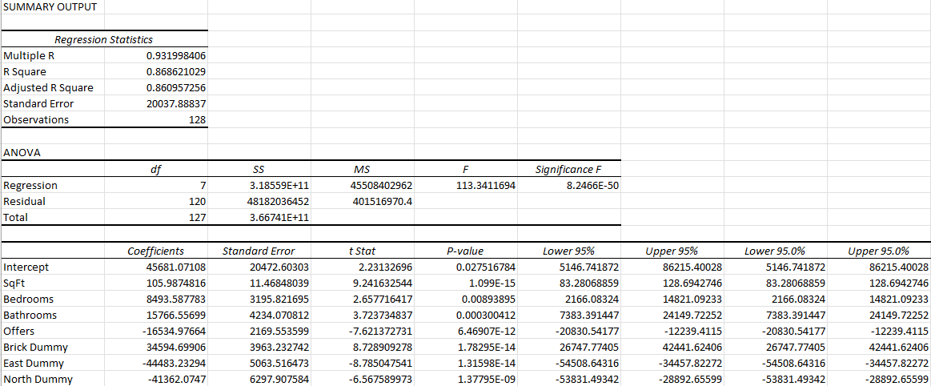

  - Which variables are statistically significant? (4%)

Square feet, bedrooms, bathrooms, offers, brick, east, and north are all statistically significant predictors of price at p < 0.05.

  - What does each coefficient mean in business terms? (4%)

Square Footage: Each additional square foot is associated with a $105.99 increase in house price.

Bedrooms: Each additional bedroom is associated with an $8,493.59 increase in house price.

Bathrooms: Each additional bathroom is associated with a $15,766.56 increase in house price.

Offers: Each additional offer is associated with a $16,534.98 decrease in house price.

Brick: A brick home is associated with a $34,594.70 increase in house price compared with a non-brick home.

East: A home in the East neighborhood is associated with a $44,483.23 decrease in house price compared with the West.

North: A home in the North neighborhood is associated with a $41,362.07 decrease in house price compared with the West.

Intercept: The model predicts a baseline price of $45,681.07 for a reference property (West, non-brick, with all other variables equal to zero).

  - Are these coefficients intuitive? If not, why not? (4%)

Most of the coefficients are intuitive. Larger homes, more bedrooms and bathrooms, and brick construction all add value, and bathrooms adding more than bedrooms is reasonable given their cost and buyer appeal. The location effects also make sense: East and North homes sell for less than the baseline West, making West the most desirable area.
The offers coefficient is counterintuitive: each additional offer is associated with a roughly $16,500 decrease in price. This reflects correlation rather than causation - lower-priced homes tend to draw more offers, so a high number of offers signals affordability rather than a decline in value.

  - What does the R-squared mean in business terms? (4%)

R-square value of 0.8686 means that 86.86% of the change in home prices is explained by the change in the other variables included in the model (Square Footage, Bedrooms, Bathrooms, Offers, Brick, East, and North).

- Create a spreadsheet prediction and sensitivity analysis of the regression model from part 6. (10% total)

  - Create a prediction model. Copy the prediction model into your report. (5%)

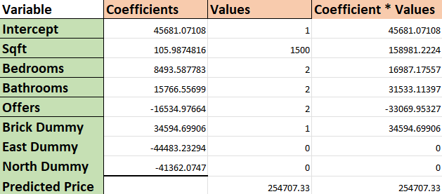

  - Perform a two-way sensitivity analysis and use conditional formatting to highlight the results. Vary two of the following variables: square feet, bedrooms, bathrooms (your choice). Copy the sensitivity analysis into your report. (5%)

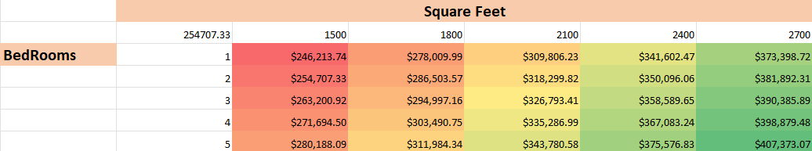

- Discussion (5% total)

  - What additional data would improve your models? Provide at least five additional different characteristics important in determining home prices. (5%)

- Age of the home / year built - Older homes typically sell for less due to wear and outdated systems, while newer builds command a premium.

- Lot size - Larger lots add value through more yard, privacy, and development potential, independent of the house's interior size.

- Garage / parking spaces - Covered, secure parking is a well-established price driver, especially where off-street parking is scarce.

- Condition / quality of finishes (or recent renovations) - Identical homes sell for very different prices depending on updates and upkeep, which size variables don't capture.

- Proximity to amenities and school quality - Access to good schools, shopping, jobs, and transit strongly shapes desirability and price.

Justify your answers. Provide a snapshot of each output from your analysis in your final paper.

